-------------------------------------------------------------------------------------------------------------------------------

USE eqcas

GO

IF(exists(SELECT 1 FROM SYSOBJECTS WHERE NAME = 'view_usersexport'))

BEGIN

DROP VIEW view_usersexport

END

GO

CREATE VIEW view_usersexport AS

SELECT

      (CASE WHEN val.state = '1' THEN 'add' end) AS action,

      (CASE WHEN val.valtype = 'usr' THEN 'ur' end) AS type,

      val.name,

      val.balance,

      u.fullname,

      val.hardlimit,

      u.email,

      (CASE ISNULL (dept.name,'NA') WHEN 'NA' THEN '' ELSE dept.name END) AS deptname,

      (CASE ISNULL (val.primarypin,'NA') WHEN 'NA' THEN '' ELSE val.primarypin END)AS primarypin,

      val.secondarypin,

      u.colorquota,

      (CASE ISNULL (altpin.primarypin,'NA') WHEN 'NA' THEN '' ELSE altpin.primarypin END) AS alternatepin,

      u.homedre,

      (CASE WHEN val.state ='1' THEN ''END)AS locked,

      (CASE ISNULL (l.name,'NA') WHEN 'NA' THEN '' ELSE l.name END) AS location

FROM cat_validation AS val

INNER JOIN cas_user_ext AS u ON u.x_id=val.id

LEFT JOIN cas_location AS l ON l.id=val.locationid

LEFT JOIN cas_val_assoc AS usr ON usr.associd=val.id

LEFT JOIN cat_validation AS dept ON dept.id=usr.mainid

LEFT JOIN cas_primarypin_ext AS altpin ON altpin.x_id=val.id

WHERE

      (val.expiration IS NULL) AND (val.valtype = N'usr') AND (val.state = 1)

GO

-------------------------------------------------------------------------------------------------------------------------------

View is created:

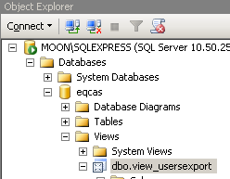

Only this user is available:

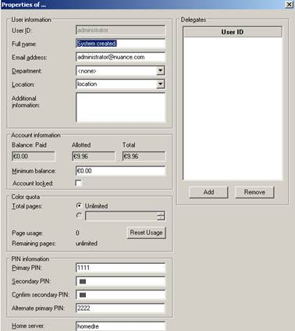

Information after select top 1000:

cid:image008.png@01CD6B60.E9B41CA0

When ‘Encryption\Store secondary PIN encryption’ is disabled you can see plain text secondary PIN.

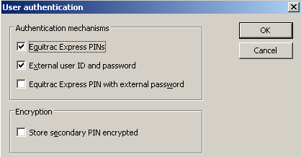

cid:image012.png@01CD6B60.E9B41CA0

**1] Export data from the view with Bcp.**

**Batch file:**

@echo off

cd "C:\Program Files\Microsoft SQL Server\100\Tools\Binn\"

rem bcp "select username,userdescription from eqcas.dbo.view_users" queryout usercode.csv /Ueqcas /Peqcas /S.\SQLExpress /T /c /t,

rem add,ur,[user_ID],[current balance],[user_name],[min_bal],[email],[dept_name],[PrimaryPIN],[SecondaryPIN],[Color_Quota],[AlternatePIN],[HomeDRE],[Locked],[Location]

bcp "select action,type,name,balance,fullname,hardlimit,email,deptname,primarypin,secondarypin,colorquota,alternatepin,homedre,locked,location from eqcas.dbo.View_UsersExport" queryout "C:\Documents and Settings\Administrator\Desktop\usersexport.csv" /Ueqcas /Peqcas /S.\SQLEXPRESS /T /c /t,

pause



Data       => add,ur,administrator,9.96000,System created.,.00000,administrator@nuance.com,dept,1111,3ABF85A2C20C4E29CDC01477FC1A9243,-1,2222,homedre, ,location

**Note:** When disabling secondary pin encryption would export the plain text secondary PIN.



Data       => add,ur,administrator,9.96000,System created.,.00000,administrator@nuance.com,dept,1111,1111,-1,2222,homedre, ,location

**2] Import data from the created usersexport.csv that we have created in step 1.**

**Batch file:**

@echo off

cd "C:\Program Files\Equitrac\Express\Tools"

eqcmd -smoon -f"C:\Documents and Settings\Administrator\Desktop\usersexport.csv"

pause

Examples of user that is recreated with encrypted and plain text secondary PIN .

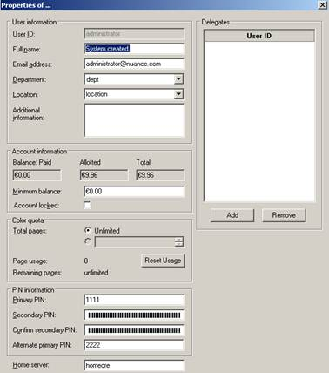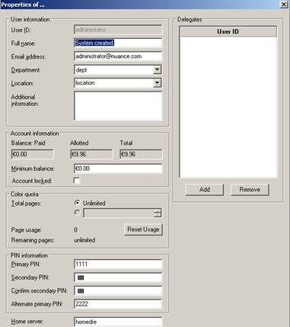

**Note:** Take care that the department is still, otherwise there would be an error message.