-------------------------------------------------------------------------------------------------------------------------------

USE eqcas

GO

SELECT

(CASE WHEN val.state = '1' THEN 'add' end) AS action,

(CASE WHEN val.valtype = 'usr' THEN 'ur' end) AS type,

val.name,

val.balance,

u.fullname,

val.hardlimit,

u.email,

(CASE ISNULL (dept.name,'NA') WHEN 'NA' THEN '' ELSE dept.name END) AS deptname,

(CASE ISNULL (val.primarypin,'NA') WHEN 'NA' THEN '' ELSE val.primarypin END)AS primarypin,

val.secondarypin,

u.colorquota,

(CASE ISNULL (altpin.primarypin,'NA') WHEN 'NA' THEN '' ELSE altpin.primarypin END) AS alternatepin,

u.homedre,

(CASE WHEN val.state ='1' THEN ''END)AS locked,

(CASE ISNULL (l.name,'NA') WHEN 'NA' THEN '' ELSE l.name END) AS location,

'0'AS default_bc,

u.additionalinfo,

u.homefolder

FROM cat_validation AS val

INNER JOIN cas_user_ext AS u ON u.x_id=val.id

LEFT JOIN cas_location AS l ON l.id=val.locationid

LEFT JOIN cas_val_assoc AS usr ON usr.associd=val.id

LEFT JOIN cat_validation AS dept ON dept.id=usr.mainid

LEFT JOIN cas_primarypin_ext AS altpin ON altpin.x_id=val.id

WHERE

(val.expiration IS NULL) AND (val.valtype = N'usr') AND (val.state = 1)

GO

-------------------------------------------------------------------------------------------------------------------------------

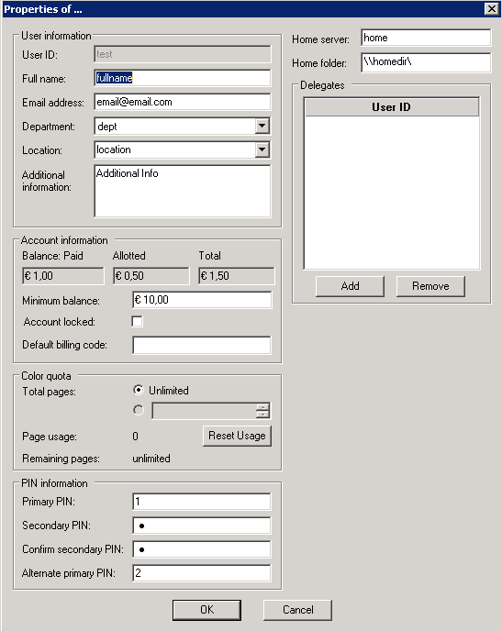

When secondary pin is encrypted, you can’t use the exported secondary pin.



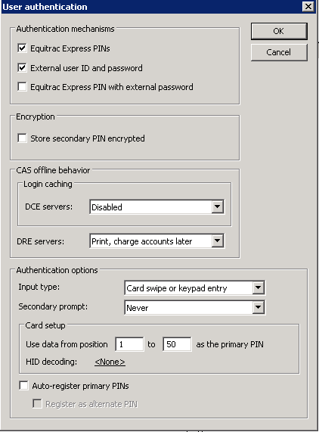

After disabling secondary pin encryption, you now are able to see the secondary pin and use it to import again.

